**Final Year B. Tech., Sem VII 2022-23**

**Cryptography And Network Security**

**PRN/ Roll No: 2020BTECS00206**

**Full Name: SAYALI YOGESH DESAI**

**Batch: B4**

**Assignment No. 2**

1. **Aim:**

Given a cipher text, encrypted Caesar using, cryptanalysis find the plain text.

1. **Theory:**

Caesar Cipher: It is a substitution cipher, i.e., each letter of a given text is replaced by a letter with a fixed number of positions down the alphabet We will decrypt using all the possible key, and find the most relative plain text.

1. **Code:**

#include<bits/stdc++.h>

using namespace std;

int main()

{

set<string> dict;

dict.insert("i");

dict.insert("am");

dict.insert("in");

dict.insert("cns");

dict.insert("lab");

dict.insert("for");

dict.insert("LA");

string s, org;

cout << "Enter Cipher text" << endl;

getline(cin, s);

string x;

int k = 0;

cout << "\nCipher text is: " << s << endl << endl;

org = s;

for (int k = 0; k < 26; k++)

{

cout << "Keep Key as: " << k << endl;

s = org;

string word = "";

int flg = 0;

for (int i = 0; i < s.length(); i++)

{

if (s[i] == ' ')

{

if (dict.find(word) == dict.end())

{

flg = 1;

break;

}

word = "";

continue;

}

int val = s[i] - 'a';

val = (val - k + 26) % 26;

char ch = 'a' + val;

word += ch;

s[i] = ch;

}

if (dict.find(word) == dict.end())

{

flg = 1;

}

if (flg == 0)

cout << s << endl << endl;

}

}

1. **Output:**

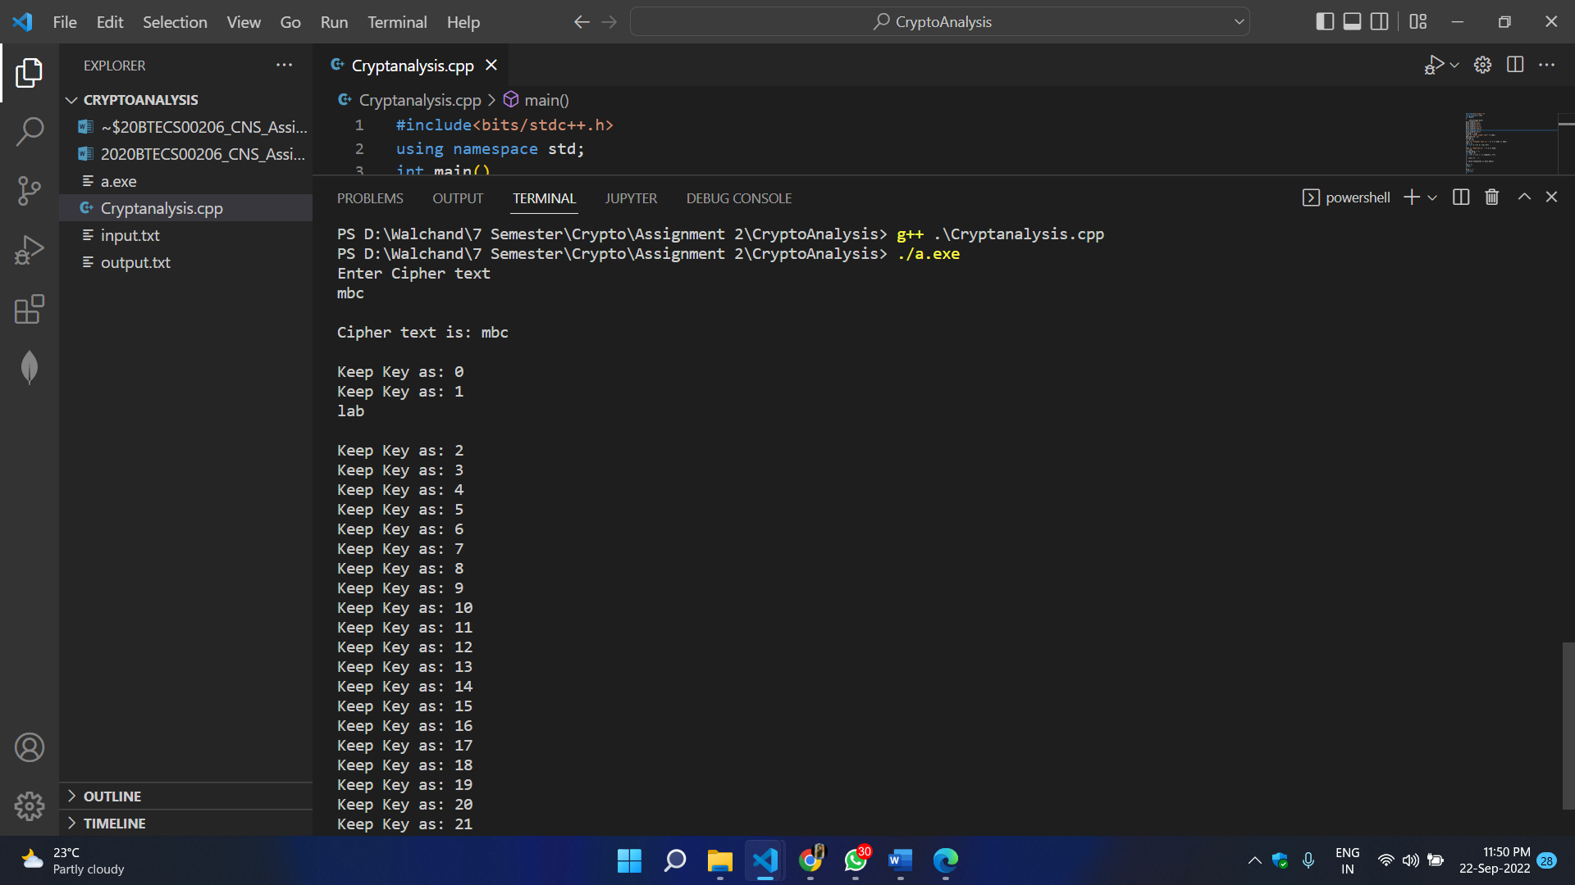

1. **Conclusion:**

Successfully decrypted the cipher text and displayed plain text using cryptanalysis.